Steps of my work:
- I loaded my trail-a.csv file into weak explorer
- I pressed on the cluster button
- 3. I have chosen the SimplekMeans
- I have chosen this method because if that Euclidean distance is used for data points in Euclidean space.
- I have chosen my data measured in Euclidean distance, where we use the sum of the squared error (SSE).
- I chose first K initial that is the number of cluster, which is 20.
- The number of iteration is 100 to have more accuracy results.
- I ignored two attributes ,RecordID and patientID
- I visualized all the clusters we can figure out the each data points assigned into appropriate closest centroid cluster.
1. Figure one: this ship for all 20 clusters



The plotting based on: Plot: 00:32:44 - SimpleKMeans (temp)
Instance: 775
Instance_number : 774.0
RecordID : 2218.0
PatientID : 646.0
Record Count : 2.0
Interval : 318.12
Patient-Sex : F
Age : 75.0
Patient-Race : 88.0
Patient-Ethnicity : 1.0
Patient-Disposition : 1.0
Length of Stay : 2.0
Admit-Type : 1.0
Admit-Source : 7.0
Hospital-ID : 38.0
Region-ID : E
Principal-Dx-Code : 78650.0

- Figure two.
the visualized of the patient-Sex:
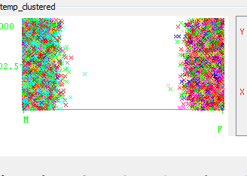

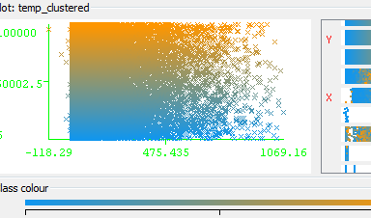

We can find out from those two figures that K-mean separates all data set for female and male into different clusters based on centroids

